# TRP API LOCAL ENVIRONMENT SETUP

## PREREQUISITES

1. Visual Studio 2015

<https://www.visualstudio.com/ru/downloads/>

1. Oracle Developer Tools for Visual Studio 2015

<http://www.oracle.com/technetwork/topics/dotnet/downloads/odacmsidownload-2745497.html>

1. GIT

<https://git-scm.com/downloads>

1. Fiddler (or some other HTTP client)

[http://www.telerik.com/fiddler](http://www.telerik.com/fiddler%20JoinMongoDev.cmd)

1. Robomongo

<https://download.robomongo.org/0.9.0/windows/robomongo-0.9.0-windows-x86_64-0786489.exe>

1. Mongo binaries: mongodb-win32-x86_64-enterprise-windows-64-3.2.11

<http://downloads.mongodb.org/win32/mongodb-win32-x86_64-2008plus-ssl-3.2.11.zip?_ga=1.221843544.1173044908.1479889107>

## LOCAL MONGO INSTALL

1. Remove the following lines from file <source>\server\install\web\PackageCreationAutomatedScript_mongo\configuration\templates\sptTemplates\SptPackageTemplate\config\

auth=true

keyFile=c:\MongoDB\Server\3.2.11\bin\mkey

1. Copy binaries from mongodb-win32-x86_64-enterprise-windows-64-3.2.11\bin to <source>\server\install\web\PackageCreationAutomatedScript_mongo\configuration\templates\sptTemplates\SptPackageTemplate\bin\
2. Go to <source>\install\web\PackageCreationAutomatedScript_mongo\configuration\templates\sptTemplates\SptPackageTemplate\environment_DEV\
3. Run install_devbox.cmd (as Administrator) and wait for completion
4. Open Robomongo and connect to localhost:27017

Authentication: admin/ P@$$word1 (Auth mechanism: SCRAM-SHA-1)

1. Type the command rs.status() and verify that replica set contains all three nodes.

## SOURCE CODE

1. Checkout the repository

<https://git.sami.int.thomsonreuters.com/trc/server.git>

## BUILD THE SOLUTION

1. Open the solution in VS 2015
2. Change mongo connection string to local database in file Configs/env.dev.config.json

FROM "Host": "10.143.25.107:27017, 10.143.25.107:27018, 10.143.25.107:27019",

To "Host": "localhost:27017, localhost:27018, localhost:27019"

1. Restore all NuGet Packages
2. Run (F5) – IIS express should start <http://localhost:41227>

## TEST

1. Open Fiddler
2. Run the following query

POST [http://localhost:41227/api HTTP/1.1](http://localhost:41227/api%20HTTP/1.1)

Accept: application/json, text/plain, */*

X-Tr-Applicationid: TRPI

X-TR-UUID: PAXTRA79330

Accept-Encoding: gzip, deflate

{

"Entity": {

"W": {},

"E": "TRPProjects"

}

}

# TRP GUI LOCAL ENVIRONMENT SETUP

## PREREQUISITES

1. Dev Environment suitable for JS development, for example Visual Studio Code

<https://code.visualstudio.com/>

1. Node.js - use 4.* LTS version.
2. Gulp: npm i -g gulp

## SOURCE CODE

1. Checkout the repository

<https://git.sami.int.thomsonreuters.com/trc/gui.git>

## PROJECT PRE-CONFIG

1. Move to the root project folder and run: npm i

## MAKE LOCAL TRP GUI USE LOCAL TRP API

1. Disable authentication:

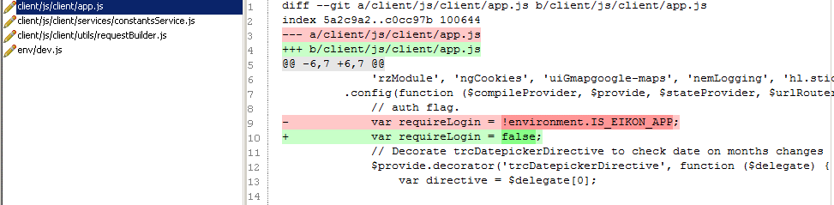

1. Uncomment UUID header:

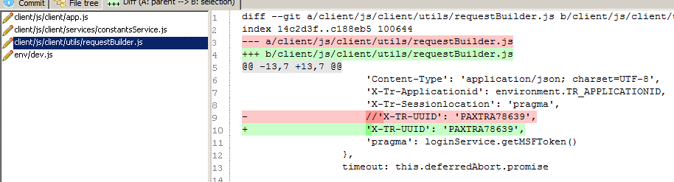

1. Change URLs

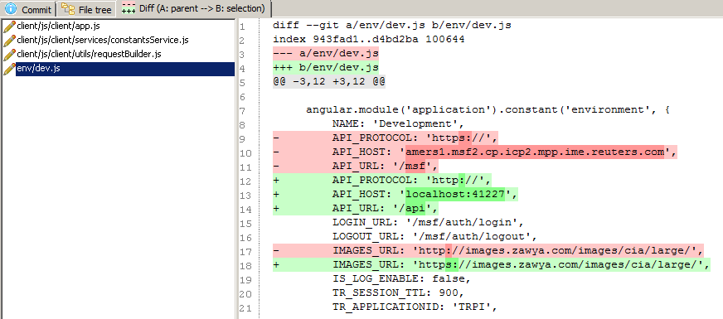

## TO RUN

1. To run application in development mode run move to the root project folder and run:

gulp dev

1. Web page will be opened automatically <http://localhost:8000>